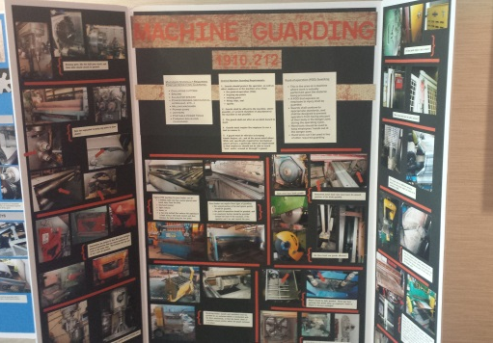
Virginia Occupational Safety and Health Annual Conference: Poster Session
The purpose of the safety and health poster session is to present information to VOSH Conference attendees who are walking through the hallways and vendor areas. During the poster session, posters will be set up in the hallway and vendor areas as stand-alone presentations for passers-by. Topics communicated by the posters could include a specific safety and health hazard, best practices, or other noteworthy items in the occupational safety and health field.
Below are some helpful tips to consider when creating your poster for the poster session.
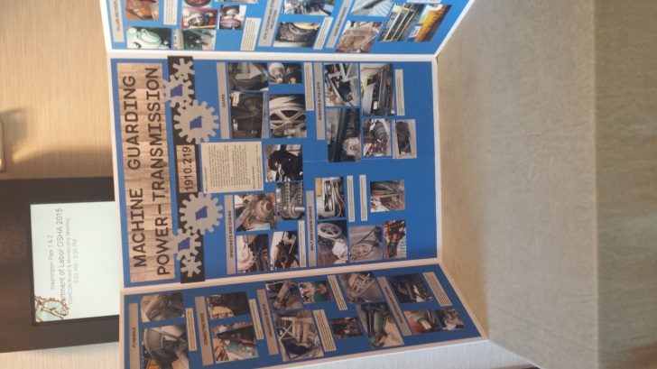
Tips for Designing a Poster
Keep it Simple
- Arrange your material in a logical progression
- Arrange materials in columns
- Don’t try to convey too much on to the poster
- The title should quickly orient the audience
- Make the title the most prominent block of text on the poster

Quickly orient the audience to the subject
- Ensure that the audience can recognize the subject within 20 seconds of seeing the poster
- Ensure that the type is large enough to be read and that enough contrast exists between the color of the type and poster's background
- Orient the poster to an audience that is not seated, but that is standing. Often the audience has distractions of noise and movement from other people. The poster should not contain large blocks of text. Neither should the poster contain long sentences. If possible, the sections should rely on images: photographs, drawings, and graphs.
- Include your name and contact information on the poster if conference attendees have questions about the topic

Ways of Making a Poster
(Tri-Fold stand up poster with maximum dimensions of 36”H x 48” W)
- Design and print a large-scale poster using PowerPoint (there is a Poster Template)
- Matte board (traditional way of making a poster):
  - Print out segments on a regular printer and cut/paste them onto matte board
  - Can use any software program (MS Word, PowerPoint, etc.)

For questions, please contact Jennifer Rose at rose.jennifer@doli.virginia.gov

